Swagger Screenshots

* GET: <https://localhost:7177/api/BloodBank>

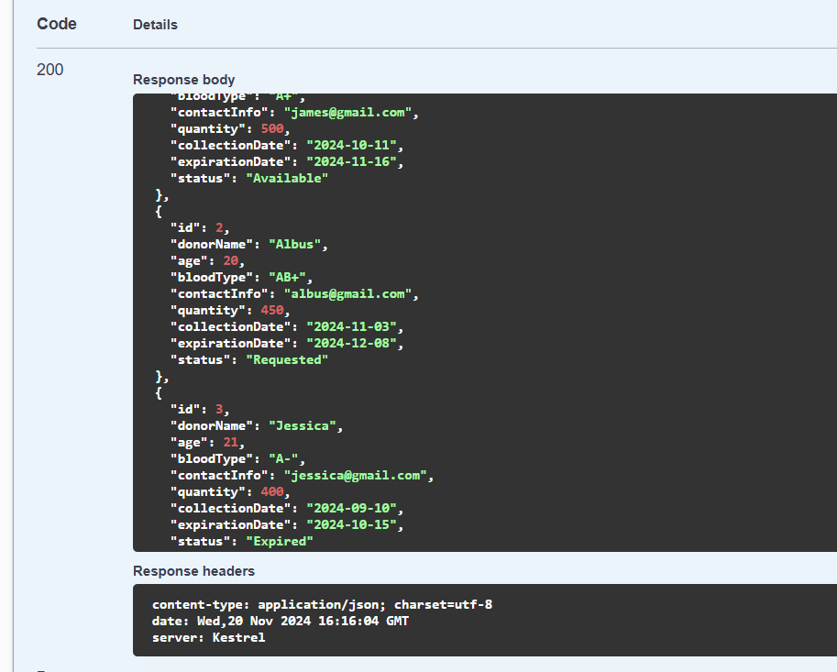

* GET: https://localhost:7177/api/BloodBank/2

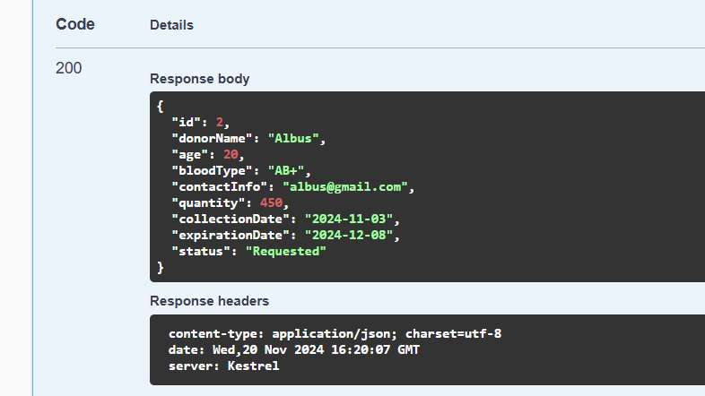

* POST: https://localhost:7177/api/BloodBank

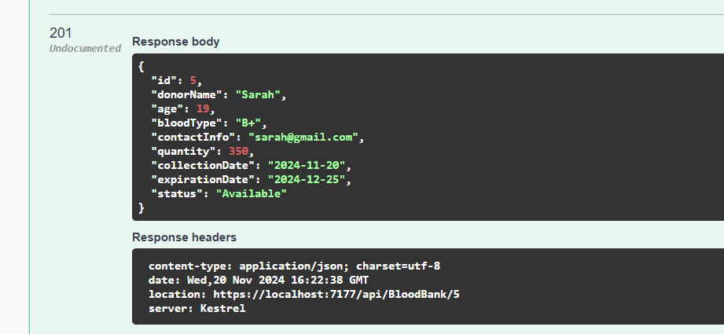

* PUT: <https://localhost:7177/api/BloodBank/5>

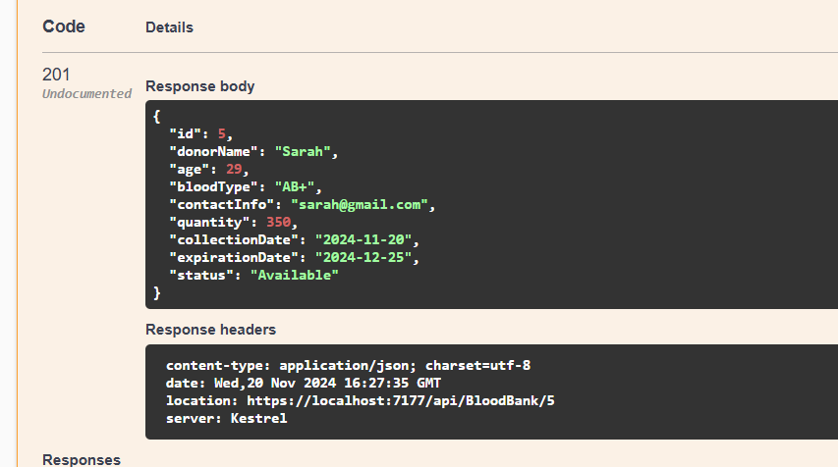

* DELETE: <https://localhost:7177/api/BloodBank/5>

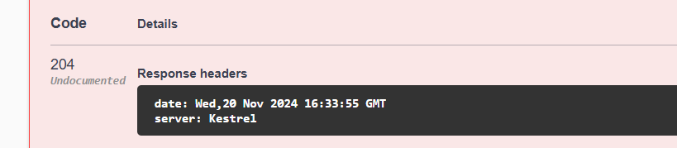

When deleting a non-existing record-

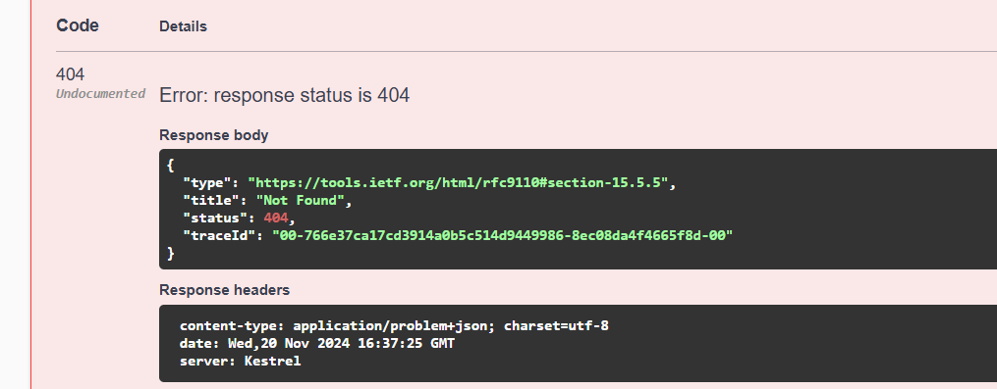

* GET: <https://localhost:7177/api/BloodBank/page=2&size=2>

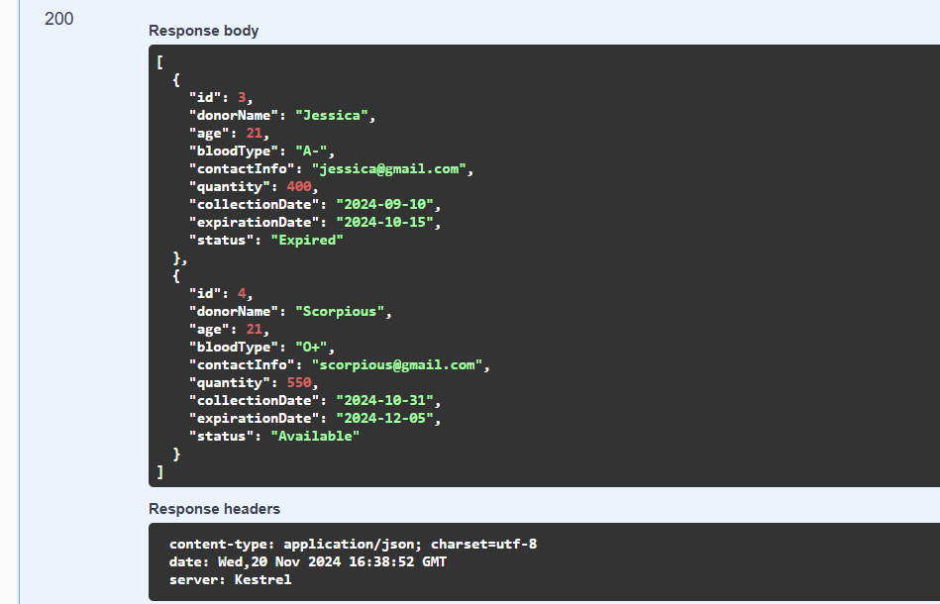

* GET: https://localhost:7177/api/BloodBank/searchbloodType=A%2B

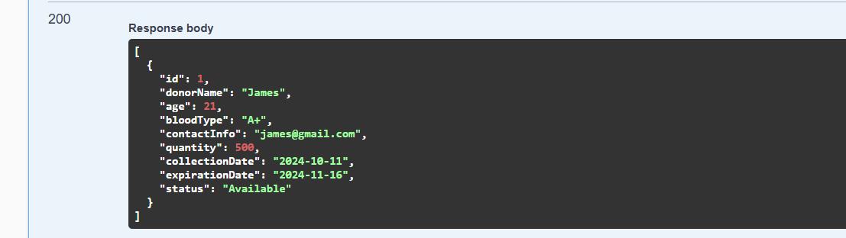

* GET: https://localhost:7177/api/BloodBank/searchstatus=Requested

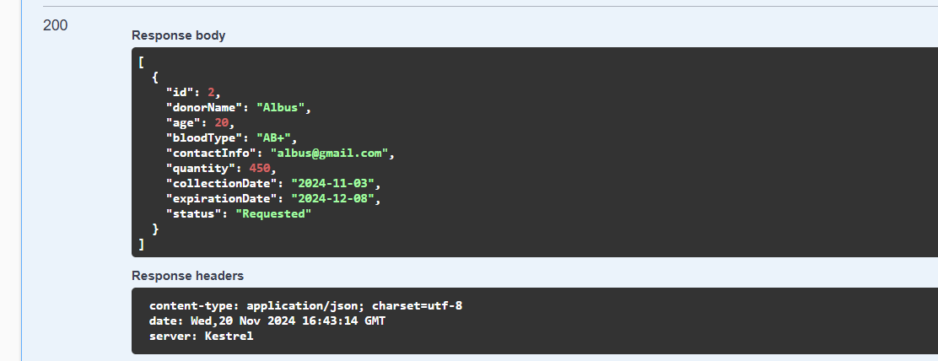

* GET: <https://localhost:7177/api/BloodBank/searchdonorName=Jessica>

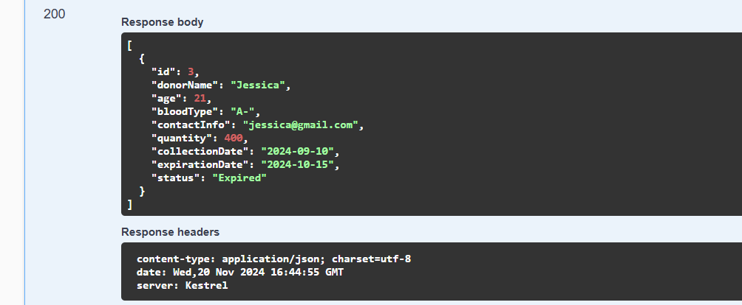

* GET: <https://localhost:7177/api/BloodBank/search?parameter=bloodtype&key=AB%2B>

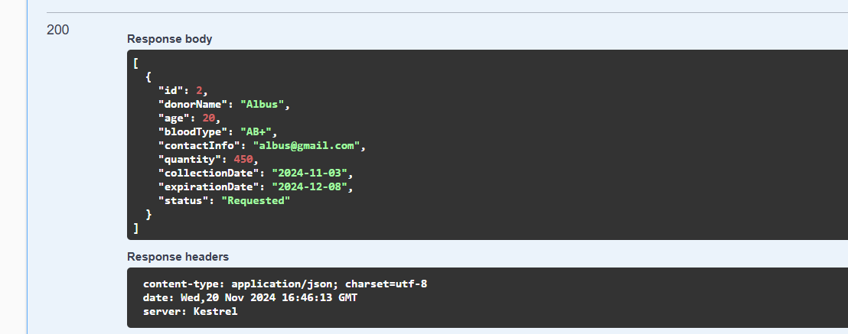

* GET: <https://localhost:7177/api/BloodBank/filter?bloodType=A%2B&status=Available>

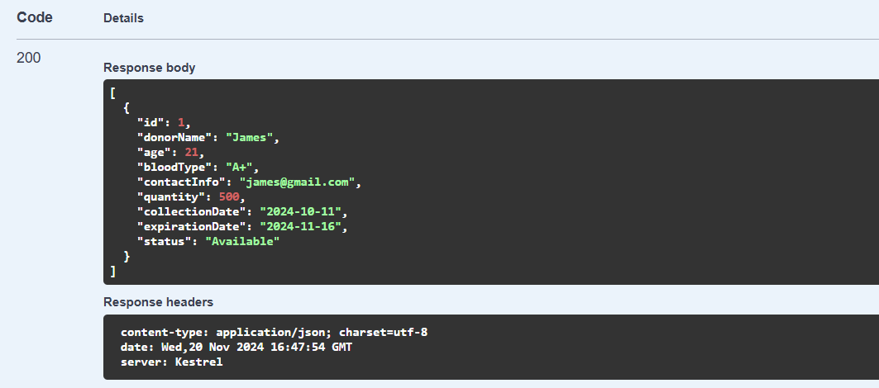

* GET: <https://localhost:7177/api/BloodBank/sort?parameter=Collectiondate&order=desc>

